**ECE 2504 – Introduction to Computer Engineering**

**Design Project 2: Design and Implementation of a Function Unit on the DE0 Nano board**

***Read the entire specification before you begin working on this project!***

**Honor Code Requirements**

Each student **must** complete this project and the associated report individually. Do not discuss any aspect of your solution or approach with anyone except for your instructor or a CEL GTA. Consider all information that you derive from your design process to be proprietary. Among other things, this includes the manner in which you implement your operations, and the number of gates that you use. Copying or using any other person’s design is a violation of the Virginia Tech Honor Code, and will be prosecuted as such. You may discuss general features of Quartus and the DE0 Nano board. Direct all other questions to your GTA or to your instructor.

**Objectives**

* Design, simulate, and implement a Function Unit from a specification.
* Write a project report describing the design process and its results.

**Preparation**

You must have access to a computer that can run Quartus. You must have a DE0 Nano board.

Read this project specification in its entirety. Consult the appropriate sections of Chapter 3 and Chapter 8 of the textbook. You should also consult the DE0 Nano board user’s manual, particularly Chapter 3 and 6. This lab follows a simplified version of the steps described in Chapter 6 of the user’s manual.

**Project Description**

A function unit is a combinational circuit that performs a variety of common arithmetic, logic, and shift operations. A function unit has a set of control inputs that determine which of the operations will be carried out on a set of operands. For this project, the function unit will take as input two 8-bit operands, A and B, and perform the operation on those operands specified by a 4-bit operation code (opcode). The function unit will generate the 8-bit result of the operation as well as four status bits. The set of operations that you are required to implement is specified in Table 1.

|  |  |  |  |
| --- | --- | --- | --- |
| **Operation name** | **Output** | **Status bits set based upon result** | **Description** |
| add | A + B | V, Z, C, N | Add A and B |
| sub | A + B’ + 1 | V, Z, C, N | Subtract B from A |
| inc | A + 1 | V, Z, C, N | Increment A by 1 |
| neg | A’ + 1 | V, Z, C, N | Negative of A |
| nand | (A ꓥ B)’ | Z, N | Bitwise NAND of A and B |
| xnor | (A ⊕ B)’ | Z, N | Bitwise XNOR of A and B |
| not | A’ | Z, N | Bitwise complement of A |
| mult4 | B × 4 | Z, N | Multiply B by 4 |
| div16 | B ÷ 16 | Z, N | Divide B by 16 |
| mod16 | B mod 16 | Z, N | Modulus of B by 16; Note if B is negative, the result has to be positive. |
| csl (circular shift left) | B << 1 | All status bits clear | Shift B left by 1 bit; the vacant bit positions are filled in with the bits that are shifted out of the sequence |
| csr  (circular shift right) | B >> 1 | All status bits clear | Shift B right by 1 bit; the vacant bit positions are filled in with the bits that are shifted out of the sequence |

Table 1: Required Function Unit operations

The status bits are defined to be the following (see Table 1 for which operations are affected):

* V: Overflow. This bit should be set to 1 when there is an overflow for an operation assuming the operands are in two’s complement; otherwise the bit should be 0.
* Z: Zero. This bit should be set to 1 when the result of an operation is equal to decimal 0; otherwise the bit should be 0.
* C: Carry out. This bit should be set to 1 when there is a carry out from the most significant bit of the result of an operation; otherwise the bit should be 0.
* N: Negative. This bit should be set to 1 when the result of an operation is negative assuming the result is in two’s complement; otherwise the bit should be 0.

The status bits should be set only for the operations as shown in Table 1. For other operations, they should be cleared.

In this project you will design, simulate and implement an 8-bit function unit that performs the operations specified above. Your function unit will be part of a larger system that will supply it with inputs and display the outputs. The larger system is shown in the schematic in Figure 1. Your responsibility is to implement the block labeled “your_FU_mux”. The rest of the system has been provided for you. The files for the project are in the Quartus archived project posted with this description.

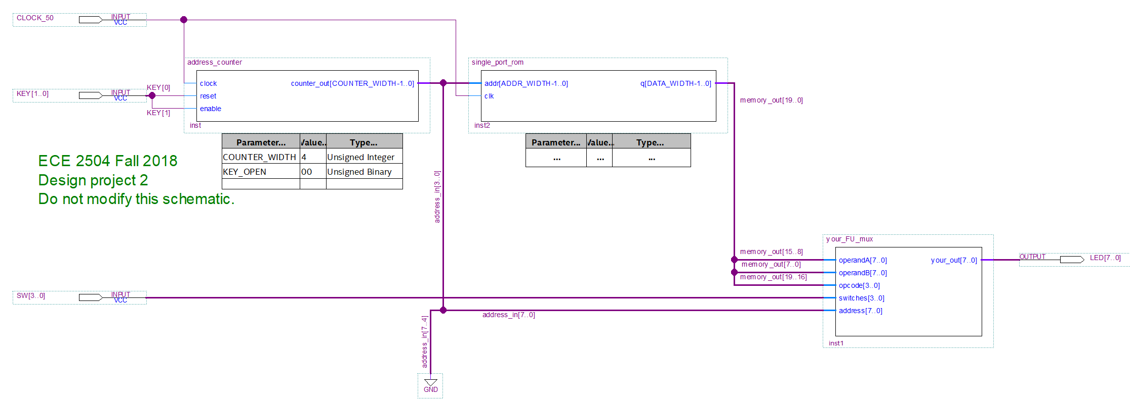

You will design and implement this module.

Figure 1. Schematic of full system for DP2. Your responsibility is to implement the “your_FU_mux” module.

The system takes as input the four DIP switches on the DE0 Nano board (SW[3:0]) and the two pushbuttons (KEY[1:0]). The pushbuttons control a counter that generates addresses for a small Read Only Memory (ROM). Each time KEY[1] is pushed and released, the counter advances to the next address in the ROM, and a new set of operands and opcode is applied to the inputs of the your_FU_mux module. KEY[0] is the reset button; after the board has been programmed, it should be pushed and released before performing any other operations to put the design into a known state. The ROM contains 16 words (addresses 0 through 15), each of which is 20 bits wide. Each word contains two 8-bit operands and a 4-bit opcode, arranged as shown in Table 2.

|  |  |  |  |  |  |  |  |  |  |  |  |  |  |  |  |  |  |  |  |
| --- | --- | --- | --- | --- | --- | --- | --- | --- | --- | --- | --- | --- | --- | --- | --- | --- | --- | --- | --- |
| 19 |  |  | 16 | 15 |  |  |  |  |  |  | 8 | 7 |  |  |  |  |  |  | 0 |
| Opcode | | | | Operand A | | | | | | | | Operand B | | | | | | | |

Table 2. Contents of each ROM address

The contents of the ROM are contained in the file called “rom.txt” in the Quartus project. Each line of the text file has the hex value for one memory location. Since each word is 20 bits wide, each line of the file has a 5 digit hex number. For example, address 0 in the “rom.txt” provided with this project is “4AA11,” which means that the opcode for first operation is 0b0100, operand A is 0xAA (-86), and operand B is 0x11 (+17).

The module your_FU_mux should contain your function unit as well as a 16-to-1 mux that controls the value displayed on the LEDs. The port declaration for the your_FU_mux module is as follows:

module your_FU_mux(your_out, operandA, operandB, opcode, switches, address);

input [7:0] operandA, operandB, address;

input [3:0] opcode, switches;

output [7:0] your_out;

As shown on the schematic, the inputs operandA, operandB, and opcode are supplied from the ROM output, while the address input is supplied by the counter. The switches input is connected to the DIP switches, SW[3:0]. The output, your_out, is connected to the LEDs, with LED[7] being the most significant bit.

The DIP switches control the 16-to-1 mux in the your_FU_mux module; the mux is used to select which value is displayed on the LEDs. The Verilog model provided for the your_FU_mux module already has an 8 bit wide, 16 to 1 mux instantiated in it with the DIP switches connected to the select lines. *You must modify the instantiation of the mux* to provide the outputs shown in Table 3. Only the binary values from 1000 to 1111 are specified; the values from 0000 to 0111 are up to you. For example, you might use them to display values from the function unit other than the result and status bits to help with debugging. Your report should include a table similar to Table 3 that lists how the LEDs were used for each combination of the switches*, including what you assigned to switch values 0000 to 0111*.

Hint: Notice that your_out is the output of the 16 × 1 mux that drives the eight LEDs on your Nano board. It is **not** the output of your ALU. Also, SW[3:0] are the select bits for the 16 × 1 mux that drives the LEDs; SW[3:0] is **not** the opcode.

You must include the last four digits of your student ID number (not PID, but student ID number) in BCD in the model using the last_four_ID_digits bus that is defined in the your_ALU_mux module. For example, if the last four digits of your ID number were “1234,” then last_four_ID_digits would be set to 16’h1234 or 16’b0001001000110100. As shown in Table 3, the LEDs should then display 0x12 for SW[3:0] = 1101 and 0x34 for SW[3:0] = 1100.

|  |  |
| --- | --- |
| **SW[3:0]** | **Value displayed on LEDs** |
| 1100 | Address |
| 1101 | Opcode, padded with leading 0’s: {4’b0000, opcode} |
| 1111 | Operand A |
| 1110 | Operand B |
| 1010 | Result |
| 1011 | Status bits, padded with leading 0’s: {4’b0000, VZCN} |
| 1001 | Left two digits of the last four digits of student ID, in BCD |
| 1000 | Right two digits of the last four digits of student ID, in BCD |
| 0XXX | Available to use as you see fit |

Table 3: DIP switch select lines and value displayed on LEDs

Hint: Notice that the SW values in Table 3 are in Gray code order rather than binary order for ease of validation.

Finally, the port declaration of the function unit is not specified. At a minimum, the ports should include the two operands and the opcode as inputs, and the result and status bits as output. You can include other inputs and outputs to help with debugging the hardware. As part of your design process, you will have to assign specific 4-bit opcode values for each operation. Do not simply assign an arbitrary opcode to a particular operation: You will find that groups of operations have similar structures such that a careful choice of the opcodes will simplify the logic for controlling the operations. Your project report must include a table showing the opcode values that you chose for each operation.

**Requirements and constraints**

1. You are permitted to modify only the Verilog file your_FU_mux.v, and the ROM contents file, rom.txt. You must not modify any other file or schematic in the project. Any additional modules that you might need to create to implement your design should be included in the your_FU_mux.v file.
2. You are not permitted to modify the port declaration of the your_FU_mux module.
3. You must implement your design using structural and dataflow Verilog constructs (gate primitives, assign statements with operators). You are not permitted to create any schematics or to use behavioral Verilog constructs (e.g., case statements, for loops). *Note that if you use dataflow Verilog it will be more difficult to determine your gate count and propagation delay.*
4. Your design must be completely combinational.
5. Your design must display the last four digits of your student ID number as shown in Table 3.

**Procedure**

The Quartus archive project file posted for this project includes the schematic and Verilog files necessary to build the system. Do not modify any files except for the rom.txt file and the your_FU_mux.v file. In particular, if you change the top level schematic or modify the pin assignments, there is a chance you could damage your DE0 Nano board.

***Step 1: Verify the behavior of the switches and pushbuttons using the provided Quartus project.*** While it does not fully implement the project, it is functional and can be synthesized and then used to program Field Programmable Gate Array (FPGA) on the DE0 Nano board using the programming instructions provided below. *Before modifying the* your_FU_mux.v *file, you should program the FPGA on the DE0 Nano board with the provided Quartus project to be sure you understand the programming procedure and the behavior of the pushbuttons and switches.* You should confirm that the switch settings behave as described in the model. As stated above, the version provided to you does not correctly implement the project specification.

***Step 2: Develop a Verilog model of the function unit (FU) by itself and test it in simulation to make sure it behaves correctly.*** You will want to create a new project in Quartus just for your function unit. (The instructions for creating a new project and simulating a model have been provided in earlier assignments; please refer to those instructions if you have any questions about those tasks.) Rather than building the whole function unit and then simulating it, you should build and simulate the function unit one operation at a time. Depending upon your design, you might create smaller functional blocks that will be used to implement the FU; if so, you should simulate each of those blocks individually to make sure they behave correctly before you connect them together into larger blocks. Include simulation results of your function unit for each operation for multiple operand values in your report. Label the results to show which operation is being tested. You should carefully consider which sets of inputs are used to test your function unit so that a wide variety of cases are covered.

Hint: Most students use some combination of highlighting, text boxes, and/or drawing tool shapes such as lines or boxes to annotate their simulations.

***Step 3: Implement your FU within the entire system.*** Once you are confident that your FU is working correctly, copy it into the your_FU_mux.v file in the provided Quartus project and instantiate it. You can then simulate the whole system. A sample simulation input file is included with the project, waveform.vwf, to give you an idea how to simulate the full project as shown in Figure 2. The counter and ROM in the schematic are sequential circuits that are positive edge triggered, so the KEY and SW inputs should not change on the positive edge of clock. Furthermore, the counter only changes the address value when KEY[1] is pushed and then released, so KEY[1] must go from 1 to 0 and back to 1 for the counter to advance. Finally, the KEY and SW values should remain steady for several clock cycles after any change in value to mimic the real hardware: the clock is running at 50 MHz, which is much (much!) faster than you can change the pushbuttons and DIP switches. Include simulation results of the whole system in your report, showing that the output behaves correctly for several combinations of switch settings and function unit operations. Label the results to show which operation is being tested.

After your model simulates satisfactorily, you must compile it and then program the DE0 Nano board with it. Please refer to sections 6.8 and 6.9 of the DE0 Nano user’s manual for full instructions. Briefly, to compile your design, double-click **Compile Design** in the Tasks window, or select **Processing**->**Start Compilation** from the toolbar. The project files provided to you will generate 4 warnings during compilation (9 if you are running multiple processors); these can be ignored. If you receive critical warnings or errors, however, you should correct them before continuing. When the compilation completes with no errors, it will generate an “SRAM Object File”, .sof, which you will use to program the FPGA on the DE0 Nano board. The *.sof file will have the same name as the project, in this case, DP2_Fall2018.sof.

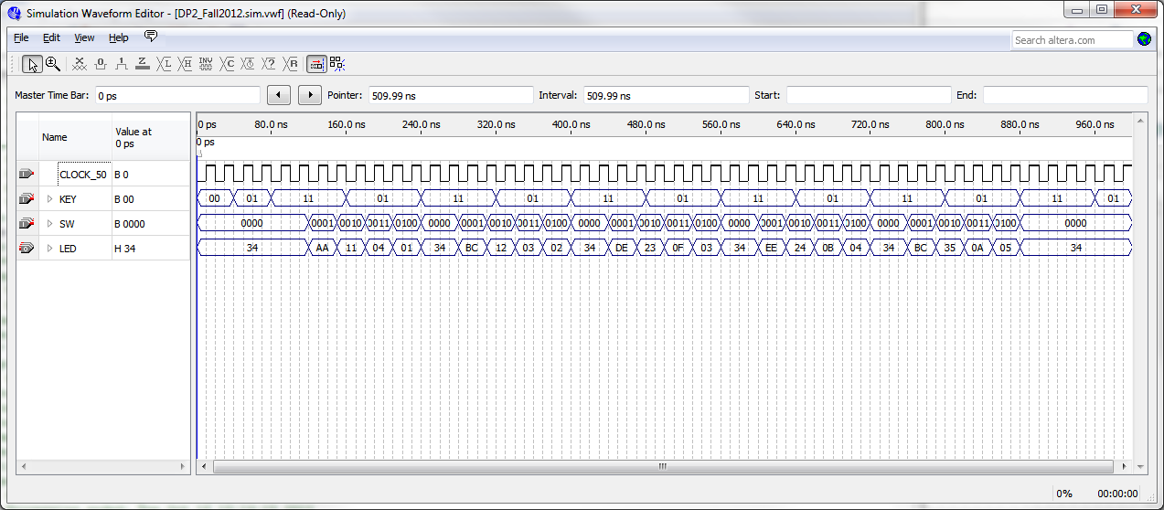

Figure 2. Sample output simulation file for testing the whole system.

When the project is successfully compiled, you can program the DE0 Nano board. Connect the board to your computer using the USB cable provided with the board. Then double-click on **Program Device (Open Programmer)** in the Tasks window, or select **Tools**->**Programmer** from the toolbar. The programmer window should open, as shown in Figure 3. The DP2_Fall2018.sof file should be shown as the file to be downloaded to the board. If it does not appear, select **Add File** and then select the DP2_Fall2018.sof file from the project directory.

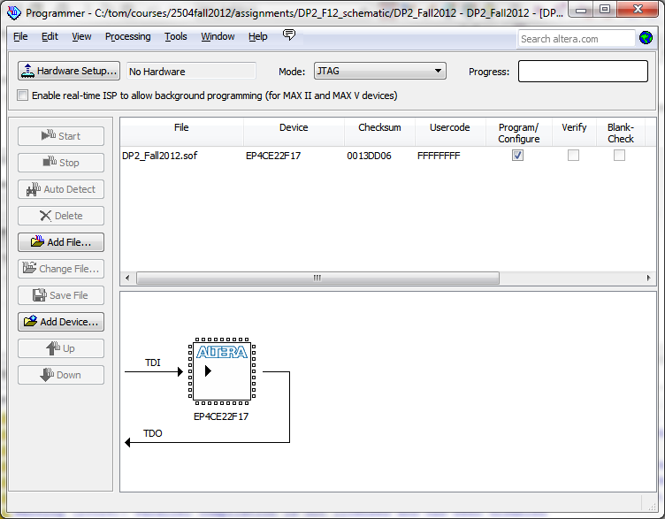

Figure 3. Programmer window.

*Important note*: The first time that you open the programmer window, you must click Hardware Setup, and turn on the **USB-Blaster [USB-0]** option under the **Currently selected hardware** pull down menu as shown in Figure 4. Then select close and return to the programmer window.

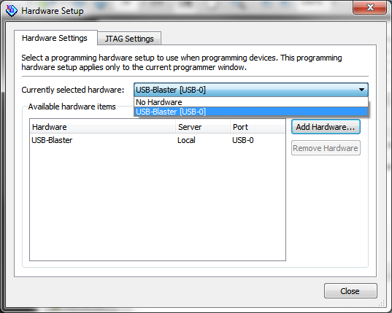

Figure 4. Choosing the USB-Blaster option on the Hardware Setup window

In the programmer window, click on the **Start** button. The start button will gray out, and the LEDs on the DE0 Nano board will dim. In a few seconds, the Progress indicator on the programmer window should turn green and say 100% (Successful). Your design has now been downloaded to the board.

To test your design, you should begin by resetting the counter by pressing and releasing the KEY0 pushbutton. You can now operate the design by using the DIP switches to control what is displayed on the LEDs and using the KEY1 pushbutton to advance to the next location in the ROM.

Using your final function unit design, determine the number of gates used and the propagation delay of the entire function unit. (This does *not* include the 16x1 mux that drives the LEDs.) Tabulate gates based on their type and number of inputs. Include this information in your report. You must include an explanation of your calculations and any assumptions.

***Step 4: Modify the rom.txt file for validation.*** Once you are confident that your design is working on the DE0 Nano board, you should change the rom.txt file so that the operations are as shown in Table 4 (all values are in decimal, but you must use hexadecimal in the rom.txt file), which will be used to validate your project in the CEL.

|  |  |  |  |
| --- | --- | --- | --- |
| **ROM address** | **operation** | **operand A** | **operand B** |
| 0 | mult8 | 74 | -25 |
| 1 | inc | -53 | 21 |
| 2 | neg | -74 | 87 |
| 3 | nand | -45 | 53 |
| 4 | xnor | 53 | -45 |
| 5 | not | -1 | 74 |
| 6 | csl | -25 | -7 |
| 7 | csr | -7 | -100 |
| 8 | add | 103 | -96 |
| 9 | sub | -67 | 93 |
| A | div16 | 38 | -100 |
| B | mod16 | 38 | -100 |

Table 4. ROM contents of addresses 0-B to be used for validation (all values are in decimal)

Hint: Notice that the operations in Table 4 are not in the same order as Table 1. Step 4 is **required** for submission and validation. Do not skip it.

**Circuit Validation**

This project does not require CEL validation. Instead, you will provide the source files that will allow the GTA to compile the same files that you used to implement your function unit on the DE0 Nano Board. Create an archive of your work by choosing ***Project > Archive Project***after you complete the implementation. When prompted for a name for your archive, the default archive name will be the same original archive. *Append your Virginia Tech PID to the end of the filename.*

When you create the archive, it should appear in the same folder that was created when you opened the original archive. Upload the archive to Canvas. *Make certain that you upload the completed archive that you created, and not the one that was provided to you.*

**Project Report**

After you have tested your function unit within the entire system, prepare and submit a written lab report that presents a detailed discussion of the project. It should include the design approach you followed, the final design you implement, the design decisions that you made and the alternatives you considered, your simulation results, your observations, and your conclusions. Subdivide your report into logical sections and label them as appropriate. The last two pages of your report must be the validation sheet. Be sure to include all the required elements. Refer to the Assignment rubric to see how this project will be graded.

**Submission Requirements:**

Submit the following files on Canvas. **Do not put them in a zip file!**

1. Your Archived Project **DP2_Fall2018_*YourPID*.QAR**
2. Your completed Verilog file **your_FU_mux.v**
3. Your modified memory file **rom.txt**
4. Your project report as a pdf or doc. Remember the ***last two pages*** should be the validation sheet. Remember to complete page 1 of the validation sheet!

**Grading**

The design project will be graded on a 100 point basis, as shown in the Assignment rubric.